Chapter 9, Problem 88.

A series audio circuit is shown in Fig. 9.88.

(a) What is the impedance of the circuit?

(b) If the frequency were halved, what would be the impedance of the circuit?

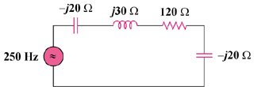

Figure 9.88
For Prob. 9.88.

